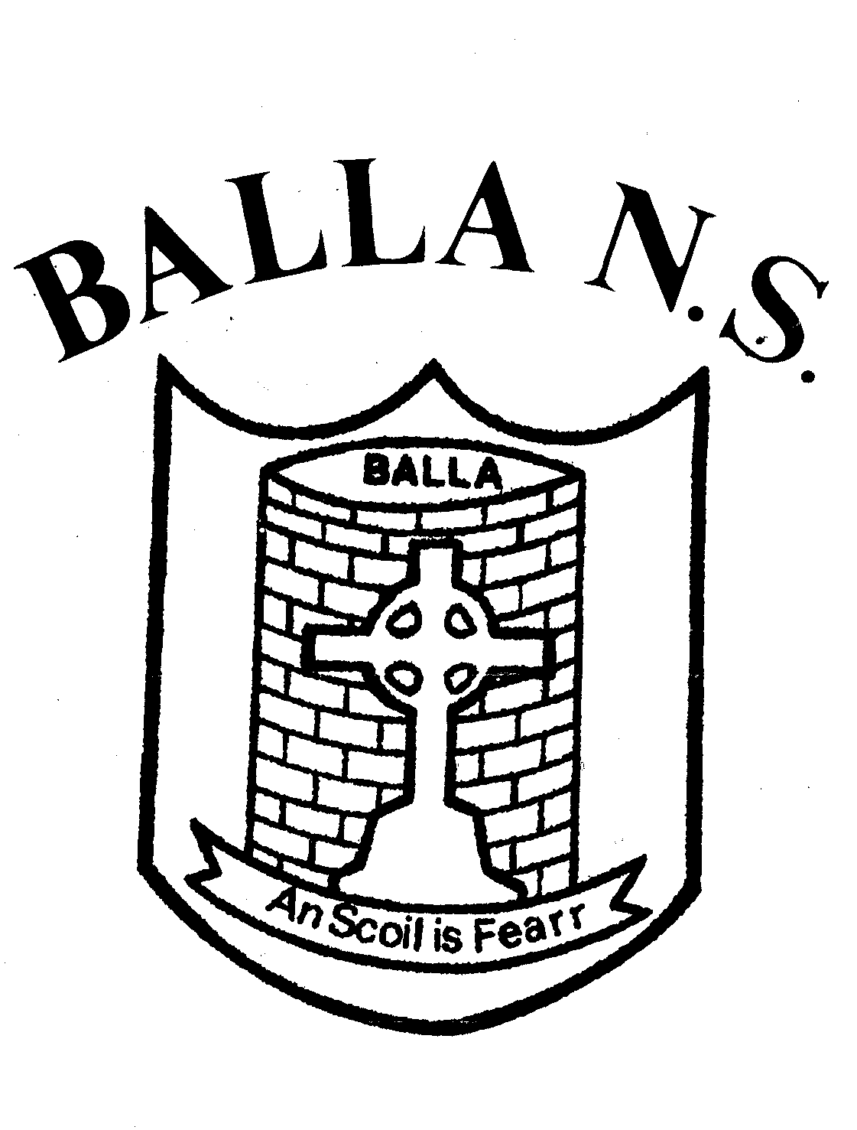
Balla National School,
Balla, Castlebar,
Co. Mayo. F23W272.
ENROLMENT FORM

Please complete in BLOCK CAPITALS |  | CLASS to be enrolled:
Pupil's Name: |  | Name in Irish:  (Optional)
Date of Birth: |  | Male/Female
P.P.S. Number: |  | Country of Birth:
Address: |  | Nationality:
 |  | If born outside the country, year of arrival in Ireland:
Eircode: |  | Languages spoken in the home:
Parent/Guardian Details |  | Parent/Guardian Details
First Name: |  | First Name:
Last Name: |  | Last Name:
Occupation: |  | Occupation:
Phone No (Home): |  | Phone No (Home):
Phone No (Work): |  | Phone No (Work):
Phone No (Mobile): |  | Phone No (Mobile):
email: |  | email:
Names of brothers/sisters already in this school:

________________________________________________________________________

Names of younger brothers& sisters and years they intend to enroll:

Name | Age | Year they will attend school

Religious denomination:
If catholic, where was your child baptised? |  |  | Yes | No
Will your child participate in the Religion programme?
Previous School Details:
Name of Previous Pre-school or Primary school:
Address:
Phone No:
Additional local contact names, to be contacted in emergencies
Please give names, addresses and phone numbers of the people who have permission to collect your child from school. If there is any change in this routine please inform the school in writing.

Name: |  | Phone No:
Relationship to child:
Name: |  | Phone No:
Relationship to child:
Name: |  | Phone No:
Relationship to child:
Please tick |  |  | Yes | No
Have you attached a Birth Certificate for your child?

Please include information regarding
Psychological Reports, Speech & Language/Occupational assessment/therapy or any other reports which may be relevant.

Relevant Medical Information:
Family Doctor: | Phone No:
Any medical concern/information of relevance?
(use Administration of Medicine Policy if required)

- Do your child/children have any specific medical condition (e.g. asthma, eyesight, hearing etc.) or emotional problems which may affect your child at school (please fill out school medicine form)?
_____________________________________________________________________________________________________________________________________________________________________________________________________________________________________________________________________________________________________________________________________________________________________________________________________________________

- It is the responsibility of parent(s)/guardian(s) to notify the school of any food allergies. Do your child/children have an allergic reaction to medication or food or does your child need to have medicine administered in school (please fill out school medicine form)?

____________________________________________________________________________________________________________________________________________________________________________________________________________________________________________________________________________________________________________________________________________________________________________________________________________

Has your child any Special Educational Needs?

Details:

Consent Form

We would like your permission for the following in relation to your child
Please tick the appropriate box and sign - Both parents/guardians please sign below

Please Tick | Yes | No
Activities Outside/After School
During the school year classes may undertake activities outside the school premises e.g. visiting the church, library, playground, outings & school tours. I consent that my child may do so.
D.T. (Digital Technology)
I give consent for my child to use the ipads/computers in the school in line with our Acceptable Use Policy.
School Website/Publications: I give consent for the use of school related photographic images which include my son/daughter on the school website, or other school publications or displays. I understand that s/he will not be identified individually.
Dept. of Education & Skills
I give written parental consent to share Ethnic or Cultural Background and Religion with the Department of Education & Skills.
Medical Emergencies
I give permission for my child to receive any medical attention deemed necessary and to be taken to hospital in case of serious illness or accident.
School Policies
I have read the Balla NS Code of Behaviour (available from school on request or online) and agree that my child and I will abide by it.
I agree to familiarise myself with all school policies, agree to abide by them and agree to discuss them at an appropriate level with my child.
Competitions
I give consent to allow my child to enter school competitions and for their name and date of birth to be shared with the organisers.

I give consent to share contact information with agencies such as the HSE e.g. School Nurse/Dentist, (e.g. name, address, Phone number) etc.

During your child’s time in Balla N.S., it may be necessary from time-to-time for teachers to carry out diagnostic testing with your child on an individual basis in order to help them in their educational development. I give permission for any necessary diagnostic tests to be carried out with my child.

I give permission to allow my child to attend the Learning Support/Resource teacher if deemed necessary.

Parent's/Guardian's Signature:

I wish to enroll my child ___________________________________ in Balla National School.
I declare the above information to be correct and understand that it will be treated as confidential.
Parent's/Guardian's Signature: ________________________ __________________________

Date: __________________

